[](http://www.google.co.uk/url?sa=i&rct=j&q=&esrc=s&frm=1&source=images&cd=&cad=rja&uact=8&ved=0CAcQjRw&url=http://icons.mysitemyway.com/legacy-icon-tags/key/page/17/&ei=bUAZVd_kGYqwUbWNgjA&psig=AFQjCNFTHPvA0gEp_aN-UTUo_SFxh1Z9OQ&ust=1427804562581553)

‘Countdown to success’

Revision Tips

[](http://www.google.co.uk/url?sa=i&rct=j&q=&esrc=s&frm=1&source=images&cd=&cad=rja&uact=8&ved=0CAcQjRw&url=http://icons.mysitemyway.com/legacy-icon-tags/key/page/17/&ei=bUAZVd_kGYqwUbWNgjA&psig=AFQjCNFTHPvA0gEp_aN-UTUo_SFxh1Z9OQ&ust=1427804562581553)The Key to Successful Revision

To make sure your revision is a successful as possible you need to stay positive, try your best and make sure you’ve got the essentials covered…

1. **Be prepared**

Make sure you’ve got everything you will need to make the most of your revision: highlighters, post-its, flashcards, pens and pencils and revision guides are all essentials.



1. **It’s all in the planning**

Take the time to plan your revision; think about which subjects you need to revise and when, and create a revision timetable to keep you on track – example at the end. You can do this at getrevising.co.uk or ask someone to help you. Spacing your revision out is proven to be more effective and planning ahead will help you avoid last minute cramming!



1. **Location, location, location**

For the most effective revision you need to be sat somewhere quiet, comfortable and well lit. If you’re lucky enough to have this at home then keep the space organised to make it work for you. Otherwise you can use the facilities at school.

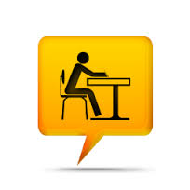

1. **Ditch the distractions**

Don’t get tempted by Insta or side tracked by Snapchat! Silence your phone, shut down your laptop, turn off your tablet and put them in another room. Good old pen and paper are your friends when it comes to effective revision!



[](http://www.google.co.uk/url?sa=i&rct=j&q=&esrc=s&frm=1&source=images&cd=&cad=rja&uact=8&ved=0CAcQjRw&url=http://icons.mysitemyway.com/legacy-icon-tags/key/page/17/&ei=bUAZVd_kGYqwUbWNgjA&psig=AFQjCNFTHPvA0gEp_aN-UTUo_SFxh1Z9OQ&ust=1427804562581553)The Key to Successful Revision

1. **Take a break**

Research shows that revising for long periods of time is not effective and will stop you from remembering important information. Revising for no more than 40 minutes and then taking a short break is shown to be ideal.



1. **Eat well & exercise**

Although it might be tempting to load up on junk food and energy drinks this could actually make your revision less effective. Eat healthily, drink lots of water and get regular exercise to boost your brain power and help you sleep better.

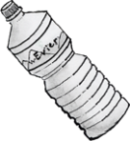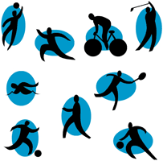

1. **Revision rewards**

Set yourself realistic revision targets and reward yourself every time you meet one! Choose something you enjoy: play a game of FIFA, meet up with friends or watch a film.



1. **The early bird gets the worm**

Revising in the morning is much better than revising late at night. Set an alarm and make an early start: the sooner you start the sooner you can finish, giving you time to relax.



Steps to Success

After you’ve got the essentials sorted, there are **four main steps** to revising effectively:

**Understand it:**



Speak to your teacher

Speak to other students

Use online resources (GCSE Pod/BBC bitesize/Seneca)

Re-read notes from exercise books

**Review it:**



Past paper questions

Test yourself

On-line tests

Ask friends/family to test you

Speak out loud for one minute

Record yourself speaking

**Remember it:**



Memorable mnemonics (first letter triggers)

Image chains

Use post-it notes around your house

Repetition, repetition, repetition

**Condense it:**



Create mind maps

Make flash cards

Make a podcast/vlog

Make lists using bullet points/flowcharts

[](http://www.google.co.uk/url?sa=i&rct=j&q=&esrc=s&frm=1&source=images&cd=&cad=rja&uact=8&ved=0CAcQjRw&url=http://adaptknowledge.com/shop/roi-survival-guide-a-dollar-and-sense-approach/&ei=JywZVZWmGYrkaqCqgrgB&v6u=https://s-v6exp1-ds.metric.gstatic.com/gen_204?ip=212.121.220.26&ts=1427713043279499&auth=42fc3i6vhduxom2xpjom6exa3tq46rq4&rndm=0.16018548275624084&v6s=2&v6t=21375&bvm=bv.89381419,d.d2s&psig=AFQjCNHOjA1wwjkcBCjSDtTGBAveXyKOuw&ust=1427799443199360)Understand It

Before you can start revising you need to understand what you need to understand! There’s no point in reading or re-reading notes if you just “*don’t get*” what you’re reading about.



**Speak to other students!**

Ask your mates to explain it to you. If you can help a friend by explaining something, do it!

**Make sure you:**



**Speak to your teacher!**

Ask questions, ask them to repeat something or explain it a different way.



**Use online resources to help you!**

There are tons of online resources available for all your subjects. Check out BBC Bitesize and GCSE Pod if you’re not sure where to start.



**Get back to books!**

Re-read your class notes.

Read & annotate revision guides.

.

Whilst you are going over the things you need to revise and checking your understanding, start breaking the information down into **Themes, Main Ideas and Details**. This will make it easier to condense and remember!

Not sure how to do this? Check out the

next page!



[](http://www.google.co.uk/url?sa=i&rct=j&q=&esrc=s&frm=1&source=images&cd=&cad=rja&uact=8&ved=0CAcQjRw&url=http://adaptknowledge.com/shop/roi-survival-guide-a-dollar-and-sense-approach/&ei=JywZVZWmGYrkaqCqgrgB&v6u=https://s-v6exp1-ds.metric.gstatic.com/gen_204?ip=212.121.220.26&ts=1427713043279499&auth=42fc3i6vhduxom2xpjom6exa3tq46rq4&rndm=0.16018548275624084&v6s=2&v6t=21375&bvm=bv.89381419,d.d2s&psig=AFQjCNHOjA1wwjkcBCjSDtTGBAveXyKOuw&ust=1427799443199360)Understand It

It’s essential that you **understand** the things you need to revise. By splitting the information up into three distinct areas, it’s much easier to make notes so you can pick out the bits you need to remember.

**THEME**

The main point of

the topic – usually

found in the title. This will give you the area you need to revise.

**MAIN IDEAS**

This gives an overview of the information within the theme. Look for repeated words and key phrases. Look at the purpose of each paragraph and pick out the main points.

**DETAILS**

These are the specific details of the topic; the information that allows you to answer questions (who, why, when, where, what and how).

**B r e a k i t d o w n …**

[](http://www.google.co.uk/url?sa=i&rct=j&q=&esrc=s&frm=1&source=images&cd=&cad=rja&uact=8&ved=0CAcQjRw&url=http://adaptknowledge.com/shop/roi-survival-guide-a-dollar-and-sense-approach/&ei=JywZVZWmGYrkaqCqgrgB&v6u=https://s-v6exp1-ds.metric.gstatic.com/gen_204?ip=212.121.220.26&ts=1427713043279499&auth=42fc3i6vhduxom2xpjom6exa3tq46rq4&rndm=0.16018548275624084&v6s=2&v6t=21375&bvm=bv.89381419,d.d2s&psig=AFQjCNHOjA1wwjkcBCjSDtTGBAveXyKOuw&ust=1427799443199360)

When using any technique for revision the important thing to remember is to break it down, bit by bit, into manageable, memorable chunks. You can do this in a mixture of ways, for example you could use a highlighter to pull out key words, or make **brief** notes in the margins and use those as your ‘Main Ideas’.

***Don’t highlight whole blocks of text because you won’t know which bit to focus on!***

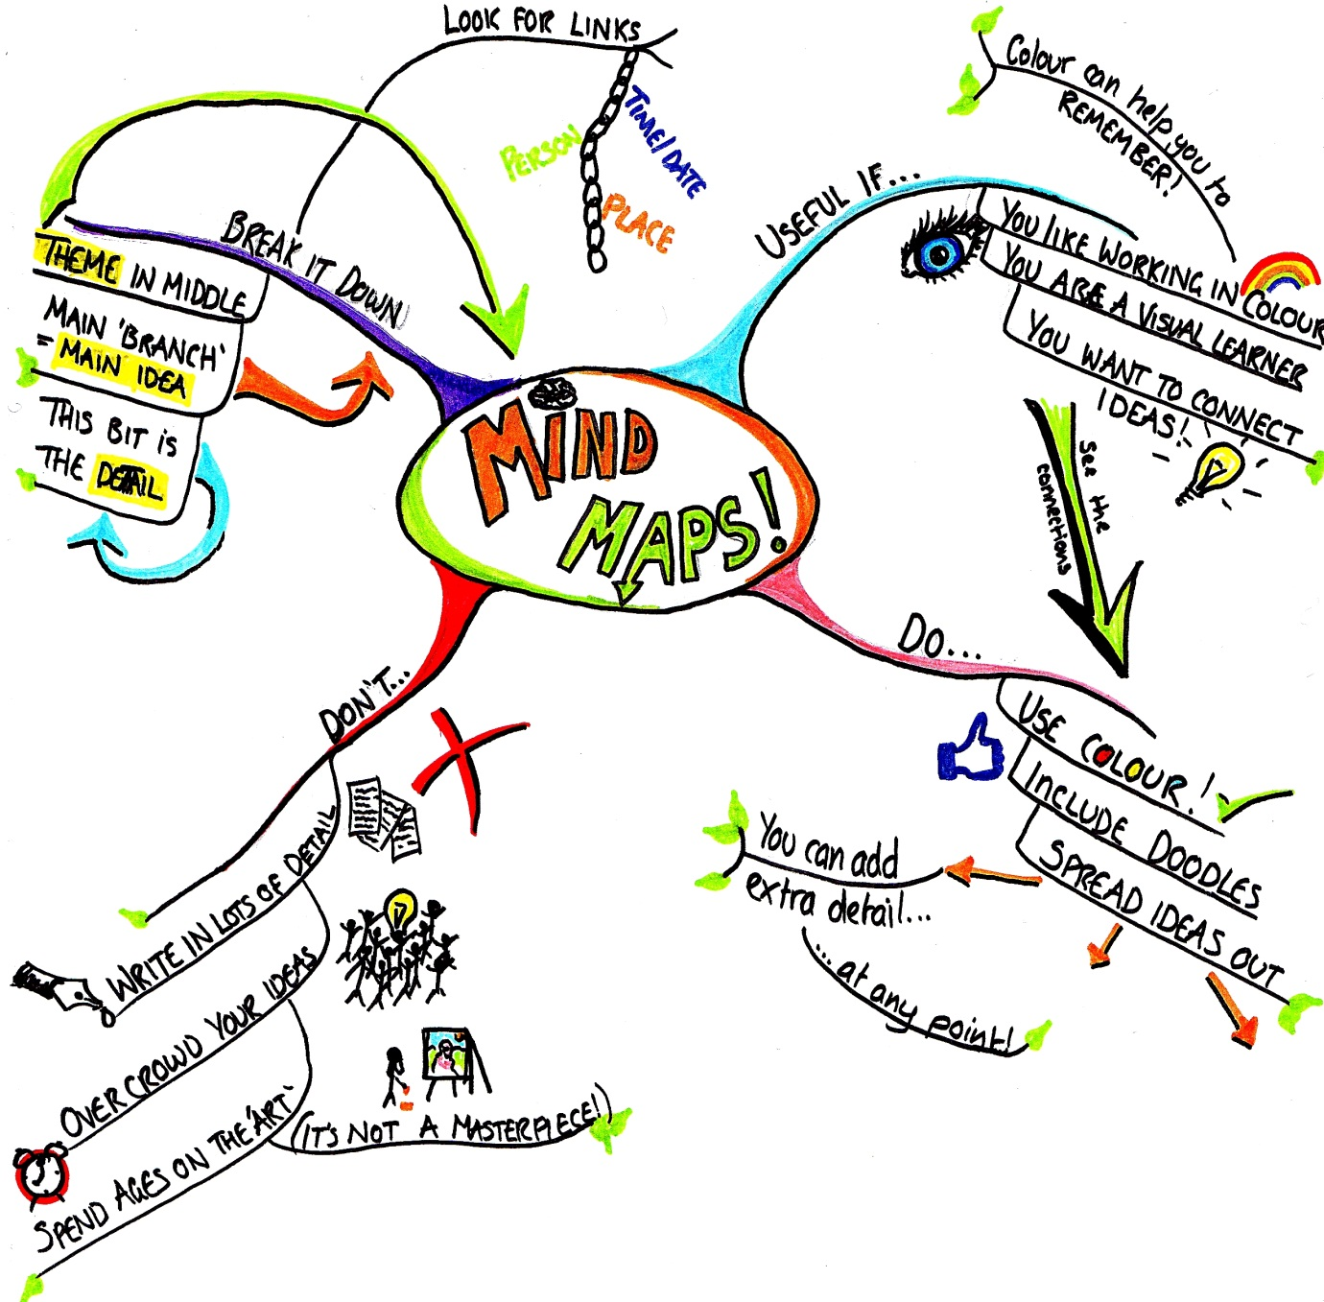[](http://www.google.co.uk/url?sa=i&rct=j&q=&esrc=s&frm=1&source=images&cd=&cad=rja&uact=8&ved=0CAcQjRw&url=http://www.123rf.com/stock-photo/arrow_rocket.html&ei=Ey0ZVeLRIM3faLXEgegP&bvm=bv.89381419,d.d2s&psig=AFQjCNHWNLeEc0dLY9otdHjqm_Qwm--1LQ&ust=1427799605685560)Condense It

**Mind maps** are very visual and use a mixture of colour, pictures and written information. The colours and pictures can act as prompts for your memory; *“I remember a key theme in Of Mice & Men is loneliness because there was a stick figure all by himself on my mind map!”*

There are many different ways to condense information. You need to try a few to find which way works best for you. You can also combine a few different approaches.

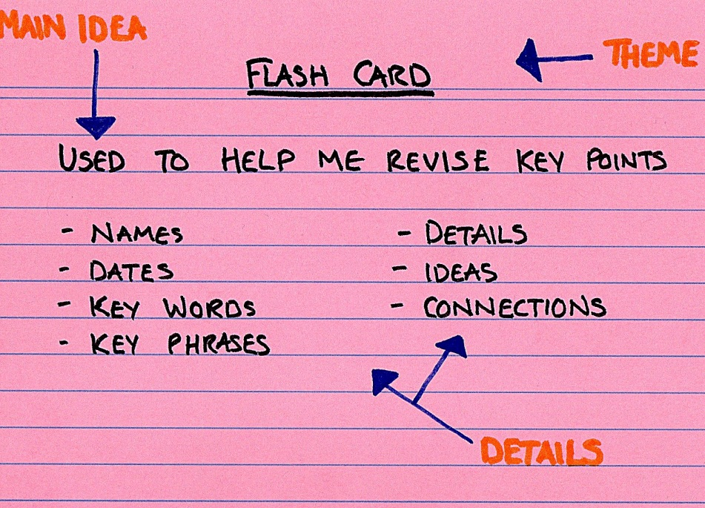[](http://www.google.co.uk/url?sa=i&rct=j&q=&esrc=s&frm=1&source=images&cd=&cad=rja&uact=8&ved=0CAcQjRw&url=http://www.123rf.com/stock-photo/arrow_rocket.html&ei=Ey0ZVeLRIM3faLXEgegP&bvm=bv.89381419,d.d2s&psig=AFQjCNHWNLeEc0dLY9otdHjqm_Qwm--1LQ&ust=1427799605685560)Condense It

**Flash cards** condense a topic down into simple key points.

They are excellent for towards the end of your revision as they can be used for self-testing or testing friends; you could even put prompt questions on the back.

**Flowcharts** are useful if you want to see how ideas connect but you don’t like using colour/pictures like in a mind map. They are somewhere in between a mind map and bullet point lists.

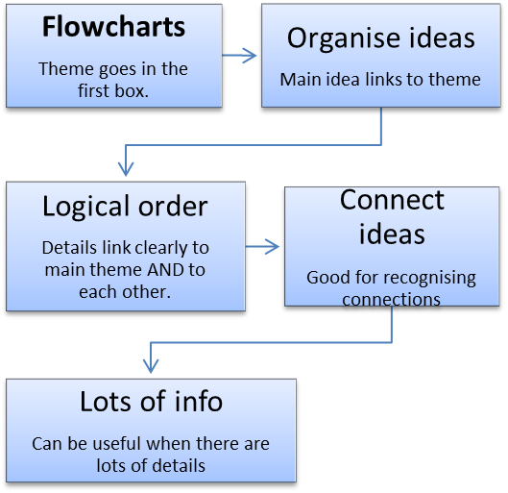

**Bullet point** lists are better if you are more of a linear/logical learner. This method can also be useful when it comes to self-testing later on; how many bits of information can you list from topic X?

**Bullet point list - Theme becomes title:**

* **Main Ideas are your main bullet points.**

**- Details are added in a ‘sub’ bullet list**

**- not too many Details for each ‘sub’ bullet**

* **Useful for getting Main Ideas on paper to work out a logical order.**

**- Details can be added later if needed**

[](http://www.google.co.uk/url?sa=i&rct=j&q=&esrc=s&frm=1&source=images&cd=&cad=rja&uact=8&ved=0CAcQjRw&url=http://pixgood.com/green-light-bulb-icon.html&ei=li8ZVavhO8LKaPPqgNAP&bvm=bv.89381419,d.d2s&psig=AFQjCNFo7xLI09tNA4RTylPX_xwAKwiLSA&ust=1427800117425534)Remember It

Remembering is an important part of learning but if something is not interesting, and not memorable, then the brain will easily forget it. You have to **train your brain** to remember! There are lots of techniques that can help make remembering information much easier.

**Here are four ways you can try when revising…**

**C:\Users\j.heil\AppData\Local\Microsoft\Windows\Temporary Internet Files\Content.IE5\T95YWFS8\tree_10_by_misteraibo-d52kzbw[1].pngC:\Users\j.heil\AppData\Local\Microsoft\Windows\Temporary Internet Files\Content.IE5\T95YWFS8\tree_10_by_misteraibo-d52kzbw[1].pngC:\Users\j.heil\AppData\Local\Microsoft\Windows\Temporary Internet Files\Content.IE5\T95YWFS8\tree_10_by_misteraibo-d52kzbw[1].pngC:\Users\j.heil\AppData\Local\Microsoft\Windows\Temporary Internet Files\Content.IE5\T95YWFS8\tree_10_by_misteraibo-d52kzbw[1].pngC:\Users\j.heil\AppData\Local\Microsoft\Windows\Temporary Internet Files\Content.IE5\T95YWFS8\tree_10_by_misteraibo-d52kzbw[1].pngC:\Users\j.heil\AppData\Local\Microsoft\Windows\Temporary Internet Files\Content.IE5\T95YWFS8\tree_10_by_misteraibo-d52kzbw[1].pngC:\Users\j.heil\AppData\Local\Microsoft\Windows\Temporary Internet Files\Content.IE5\T95YWFS8\tree_10_by_misteraibo-d52kzbw[1].pngC:\Users\j.heil\AppData\Local\Microsoft\Windows\Temporary Internet Files\Content.IE5\T95YWFS8\tree_10_by_misteraibo-d52kzbw[1].pngC:\Users\j.heil\AppData\Local\Microsoft\Windows\Temporary Internet Files\Content.IE5\T95YWFS8\tree_10_by_misteraibo-d52kzbw[1].png**

**First letter triggers**

**(mnemonics/acronyms):**

These are simple, memorable ways to

remember important facts, definitions

and key terms.

**Because**:

Big

Elephants

Can

Always

Understand

Small

Elephants



**AFORESTER**

**SMOAP**

**Image chains:**

Mainly sketches or images to remember

orders or key facts.

**Of Mice & Men**

**Key Themes**



Loneliness Friendship American

Dream

**Post-it locations:**

Short facts left in different locations really

help the brain to remember! Put post-its

on your bathroom mirror, bedroom door,

toaster etc. You will see your notes every

day and they will stick in your head!



**Mercutio’s death**

**R&J**

**Act 3 Scene 1**

**Repetition:**

Repetition is an important way to make

Sure that ideas and details can be recalled.



**Say it. Write it. Repeat it.**

[](http://www.google.co.uk/url?sa=i&rct=j&q=&esrc=s&frm=1&source=images&cd=&cad=rja&uact=8&ved=0CAcQjRw&url=http://www.olympiaautocredit.com/&ei=KTEZVdyKCsavUdn4gvgL&bvm=bv.89381419,d.d2s&psig=AFQjCNGtaJddUjyxU7HaS4xLWqN2LLgKSQ&ust=1427800658315098)Review It

Checking the work you have condensed and memorised is a vital part of your revision.

**Here are some ways you can do this…**

**Re-read:**

You’ve condensed your work, now you

need to spend time re-reading those notes,

diagrams etc.

**Test yourself:**

Speak out loud for 1 minute on a single topic.

Answer past paper questions or questions out

of a text book.

Use on-line tests such as BBC Bite-size.

See if you can answer your own ‘flash-card’

questions!

**Ask other people to test you:**

Ask friends or family to test you from your

mind-maps, flash-cards or condensed notes.

**Record yourself:**

Use a voice recorder to make short spoken

summaries.

This will help you check your summaries

make sense and also means you can listen

back to your notes wherever you are.

