
Please find enclosed revision tasks and topics from each subject for January’s non-core exams.

Exams will be held over the week two weeks from the 2nd of January and will be in pupil’s classrooms.

It is also strongly advised that students make use of BBC Bitesize for the subject area they are revising, using this booklet to find topic areas they will be assessed on.
Year 9 Revision booklet
January 2023

YEAR 9 IN CLASS EXAM TIMETABLE – 2nd January to 13th January 2023

 | Period 1 | Period 2 | Break | Period 3 | Period 4 | Lunch | Reading | Period 5
Tuesday  3rd January |  | DT Resist Mat: Year 9: Year 9 KDte6, CA3, MR  DT Textiles: Year 9: Year 9K3 Tex, CA2, LB  DT Textiles: Year 9: Year 9K2 Tex, CA7, DE  DT Resist Mat: Year 9: Year 9 KDte1, CA4, CCD  DT Food: Year 9: Year 9K5 Food, CA9, CCH
Wednesday 4th January | DT Textiles: Year 9: Year 9W2 Tex, CA5, LB  DT Food: Year 9: Year 9W4 Food, CA7, DE  DT Food: Year 9: Year 9W3 Food, CA9, NHU  DT Textiles: Year 9: Year 9W5 Tex, CA1, TW |  |  | Philosophy, Religion and Ethics: Year 9: 9W2 PRE, E4, NCR  Philosophy, Religion and Ethics: Year 9: 9W4 PRE, H9, CLM  Drama: Year 9: 9K4 Dra, PA1, DC  Music: Year 9: 9 K 2Mus, PA5, SAK  Drama: Year 9: 9W5 Dra, PA2, CD  Geography: Year 9: 9 W 1Geo, H8, KWI  Drama: Year 9: 9K5 Dra, HALL, DM  Information Tec: Year 9: 9K1 ICT, IC10, SJG  Information Tec: Year 9: 9K3 ICT, IC9, HGH | DT Textiles: Year 9: Year 9K4 Tex, CA2, LB  DT Resist Mat: Year 9: Year 9 KDte2, CA4, CCD  Art: Year 9: Year 9 KArt5, CA1, TW  Art: Year 9: Year 9 KArt1, CA8, CB  DT Food: Year 9: Year 9K6 Food, CA9, MR  DT Food: Year 9: Year 9K3 Food, CA7, DE |  |  | DT Textiles: Year 9: Year 9K4 Tex, CA2, LB  DT Resist Mat: Year 9: Year 9 KDte
Thursday  5th January | Information Tec: Year 9: 9K5 ICT, IC12, LF  Philosophy, Religion and Ethics: Year 9: 9K1 PRE, H13, NCR  Philosophy, Religion and Ethics: Year 9: 9K3 PRE, H9, RES |  |  | Information Tec: Year 9: 9K2 ICT, IC9, HGH  Drama: Year 9: 9K1 Dra, PA1, DC  Music: Year 9: 9 K 5Mus, PA4, SJ  History: Year 9: 9K3 His, H2, EFB | DT Resist Mat: Year 9: Year 9 WDte6, CA3, JD  DT Textiles: Year 9: Year 9W3 Tex, CA2, LB  Art: Year 9: Year 9 WArt4, CA8, CB  Art: Year 9: Year 9 WArt5, CA1, TW  DT Food: Year 9: Year 9W1 Food, CA9, HK |  |  | Spanish: Year 9: 9 K 2Spa, L1, LH  French: Year 9: 9K1 Fre, L6, TJR
Friday  6th January | DT Textiles: Year 9: Year 9W4 Tex, S7, DOR  DT Resist Mat: Year 9: Year 9 WDte5, CA3, MR  DT Textiles: Year 9: Year 9W1 Tex, CA2, LB  DT Resist Mat: Year 9: Year 9 WDte2, CA1, LP  Art: Year 9: Year 9 WArt3, CA6, LP, CB  DT Food: Year 9: Year 9W6 Food, CA7, DE | History: Year 9: 9K1 His, H3, HCB  Geography: Year 9: 9 K 3Geo, H11, BS  Philosophy, Religion and Ethics: Year 9: 9K4 PRE, H9, CLM  Philosophy, Religion and Ethics: Year 9: 9K5 PRE, H4, HR |  | Music: Year 9: 9 K 4Mus, PA5, SJ  Philosophy, Religion and Ethics: Year 9: 9K2 PRE, H13, NCR | Drama: Year 9: 9W1 Dra, PA1, DC  Music: Year 9: 9 W 3Mus, PA4, SJ  Information Tec: Year 9: 9W5 ICT, IC12, LF  Drama: Year 9: 9W2 Dra, PA1, CD  Music: Year 9: 9 W 4Mus, PA5, DM

 | Period 1 | Period 2 | Break | Period 3 | Period 4 | Lunch | Reading | Period 5
Monday  9th January | Spanish: Year 9: 9 W 1Spa, L6, TJR  Drama: Year 9: 9W3 Dra, PA1, CD  Information Tec: Year 9: 9W2 ICT, IC10, SJG | Geography: Year 9: 9 K 1Geo1, H12, FR  History: Year 9: 9K4 His, H4, HR  Geography: Year 9: 9 K 2Geo, H7, KWI |  | DT Textiles: Year 9: Year 9K5 Tex, CA2, LB  DT Resist Mat: Year 9: Year 9 KDte3, CA4, CCD  Art: Year 9: Year 9 KArt6, CA1, CCH  DT Food: Year 9: Year 9K4 Food, CA7, DE  DT Food: Year 9: Year 9K2 Food, CA9, MR | History: Year 9: 9W2 His, H5, JJL  French: Year 9: 9K4 Fre, L5, PJS  Information Tec: Year 9: 9W4 ICT, IC14, BPA  History: Year 9: 9W3 His, H3, HCB  French: Year 9: 9K3 Fre, L3, SM  Spanish: Year 9: 9 K 5Spa, L4, CPC  Geography: Year 9: 9 W 5Geo, H11, BS |  |  | Geography: Year 9: 9 W 2Geo, H4, RES  History: Year 9: 9W4 His, H6, AR  Music: Year 9: 9 W 5Mus, PA4, SJ  History: Year 9: 9W1 His, H1, MJT
Tuesday  10th January | Music: Year 9: 9 W 1Mus1, PA5, SAK  Information Tec: Year 9: 9W3 ICT, IC9, HGH  French: Year 9: 9W2 Fre, L6, TJR |  |  | Philosophy, Religion and Ethics: Year 9: 9W1 PRE, H13, NCR  History: Year 9: 9K2 His, H6, AR  Drama: Year 9: 9K3 Dra, PA1, DC | Geography: Year 9: 9 W 4Geo, H4, HR  Philosophy, Religion and Ethics: Year 9: 9W3 PRE, H9, CLM  Music: Year 9: 9 W 2Mus, PA4, DM
Wednesday 11th January | DT Resist Mat: Year 9: Year 9 WDte4, CA3, MR  DT Resist Mat: Year 9: Year 9 WDte3, CA4, CCH  Art: Year 9: Year 9 WArt2, CA8, CB  Art: Year 9: Year 9 WArt1, CA6, LP  DT Food: Year 9: Year 9W5 Food, CA7, DE  DT Textiles: Year 9: Year 9W6 Tex, CA1, LB | History: Year 9: 9K5 His, H6, AR  Drama: Year 9: 9K2 Dra, PA2, CD  Geography: Year 9: 9 K 4Geo, H7, RES |  |  | Geography: Year 9: 9 W 3Geo, H11, BS  History: Year 9: 9W5 His, H3, HCB
Thursday  12th January | Geography: Year 9: 9 K 5Geo, E2, HK | Drama: Year 9: 9W4 Dra, PA1, DC  Information Tec: Year 9: 9K4 ICT, IC9, HGH  Music: Year 9: 9 K 1Mus1, PA4, DM |  |  | Philosophy, Religion and Ethics: Year 9: 9W5 PRE, H9, CLM
Friday  13th January | DT Resist Mat: Year 9: Year 9 WDte1, CA3, MR  Art: Year 9: Year 9 WArt6, CA8, CB  DT Food: Year 9: Year 9W2 Food, CA7, DE |  |  | Spanish: Year 9: 9 W 3Spa, L2, LH  French: Year 9: 9W4 Fre, L3, SM  Music: Year 9: 9 K 3Mus, PA5, SAK |  |  |  | DT Resist Mat: Year 9: Year 9 KDte5, CA3, MR  DT Textiles: Year 9: Year 9K1 Tex, CA2, LB  DT Textiles: Year 9: Year 9K6 Tex, S5, DH  Art: Year 9: Year 9 KArt4, CA8, CB  Art: Year 9: Year 9 KArt3, CA1, TW  Art: Year 9: Year 9 KArt2, CA4, CCD
Monday 16th January | DT Food: Year 9: Year 9K1 Food, CA7, DE  DT Resist Mat: Year 9: Year 9 KDte4, CA3, MR


Revision information for Year 9 exams
Subject: Art
What topics should be revised?
Your exam will be an observational drawing task based on the theme of Robots! This is in preparation for your second art project called AI (Artificial Intelligence).
You will have the choice to work in the following media;
- Pencil
- Biro
- Fine Liner
You will have 45 minutes to complete the exam task.

What task should pupils do to complete the revision?
Practice drawing from the following images.
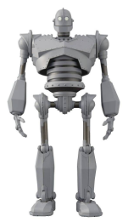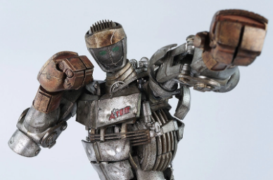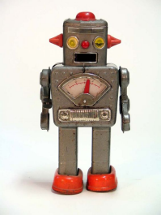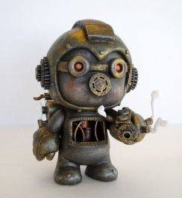
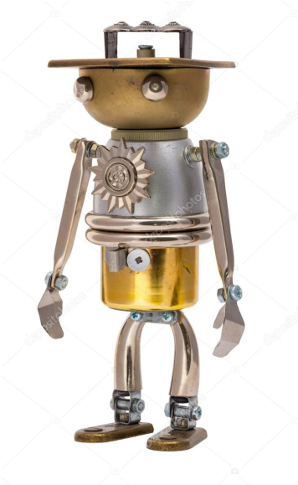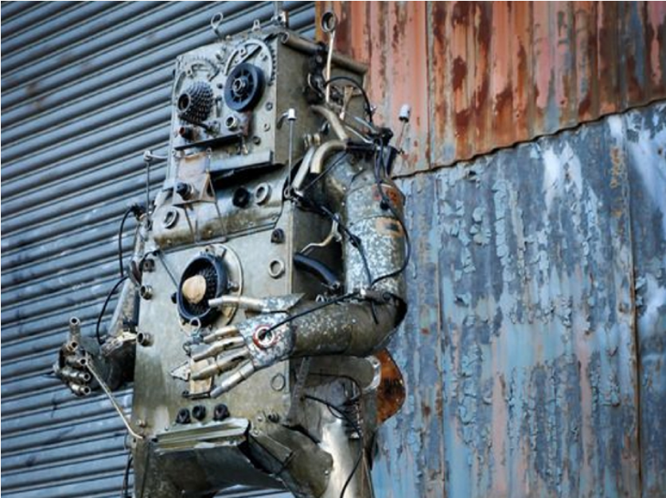

Any other relevant information for pupils
To enter the room in silence and ensure they are fully equipped for the exam.
Revision information for Year 9 exams
Subject: Drama
Please see following two pages
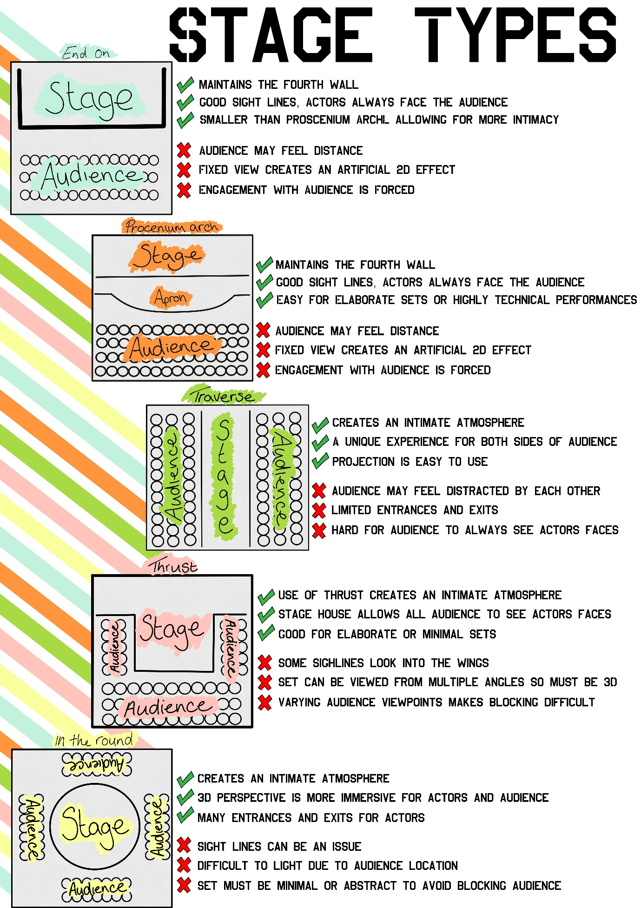

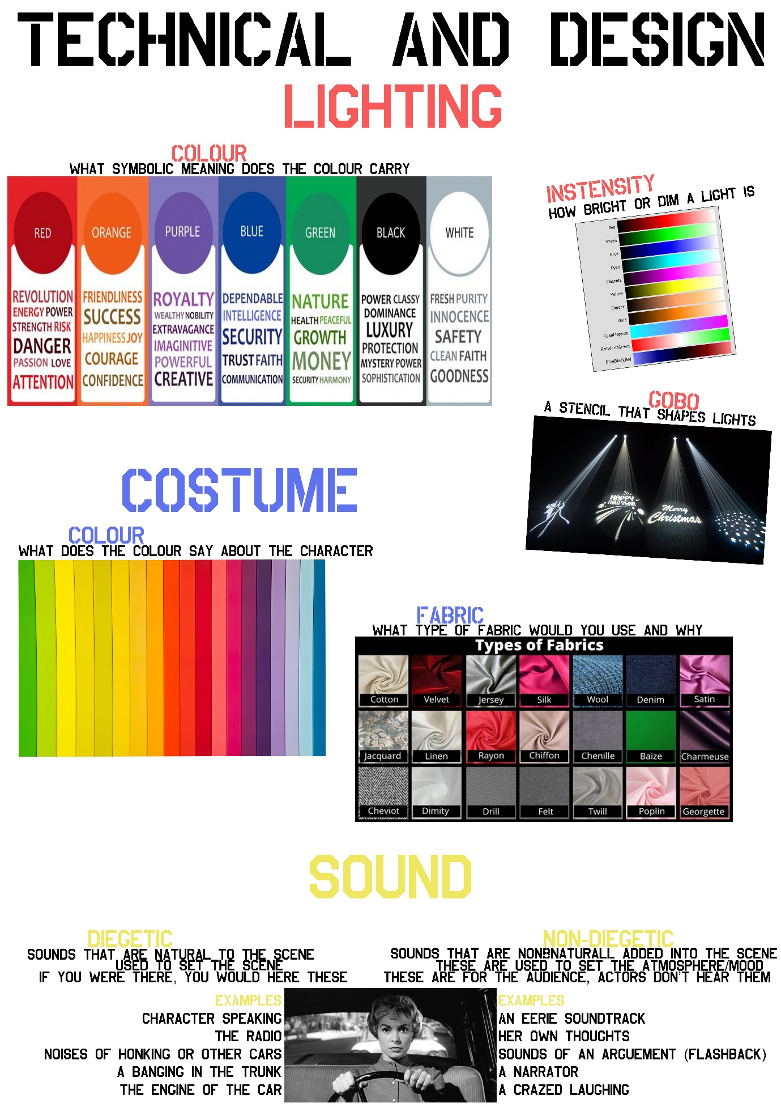
Revision information for Year 9 exams
Subject: Food
What topics should be revised?
You will need to revise all theory covered during your Food lessons so far. The exam will also require you to use your knowledge from previous years.
You will need to focus on the main elements of the eat well guide and the function of each nutrition.
You need to consider all aspects of health and safety within the food room and what precautions needs to be considered when storing, preparing and cooking with raw meat. Use of the oven and hobs will also need to be revised.
Your exam will include a design/presentation task so you will need to be prepared to design, colour and annotate using a design criteria.

What task should pupils do to complete the revision?
Ask questions in class to support learning topics you are covering.
Create flash card to memories topic such as eatwell guide.
Use the internet to research ideas for presenting dishes and what makes a good dish.

Any other relevant information for pupils
Use https://www.foodafactoflife.org.uk/ to get useful information about the subject that can help you to revise.

Revision information for Year 9 exams
Subject: French
What topics should be revised?
Personal information.
Clothes.
House and home.
Local area.
Food and drink
Present tense
Past tense
Future tense.

What task should pupils do to complete the revision?
Learn vocabulary from each topic from the progress booklets on TEAMS.
Learn key structures which could be used in any writing such as opinions, connectives, verbs, detail from the knowledge organisers on TEAMS.

Any other relevant information for pupils
You will be tested in three skills: listening, reading and writing.

Revision information for Year 9 exams
Subject: Geography
What topics should be revised?
You will need to revise:
- Development indicators – make sure you know a few examples, e.g. literacy rate and whether they are social/economic
- Human Development Index
- Differences between Low Income Countries and High Income Countries
- Factors affecting development
- Fairtrade – advantages and disadvantages

What task should pupils do to complete the revision?
- Read through your book.
- Watch some GCSE pods: https://members.gcsepod.com/shared/podcasts/title/12091/74753
- Look at BBC Bitesize: https://www.bbc.co.uk/bitesize/guides/zvp39j6/revision/1 and try this test https://www.bbc.co.uk/bitesize/guides/zvp39j6/test
- Make revision cards / mind maps / draw pictures with key words to help you remember them.
- And finally, make sure you get a get rest and lots of sleep over the holidays.

Any other relevant information for pupils
The exam will last for one hour.

Revision information for Year 9 exams
Subject: History
What topics should be revised?
Dunkirk: https://www.bbc.co.uk/bitesize/guides/z9s9q6f/revision/1
Weimar Germany and the treaty of Versailles: https://www.bbc.co.uk/bitesize/guides/zbg4t39/revision/1

What task should pupils do to complete the revision?
Complete a mind map to revise 5 facts about each topic.
Read over your previous exam answers in those skills (GREEN SHEETS IN YOUR BOOKS)

Any other relevant information for pupils
Skills you will be examined on:
- Historians interpretations (what are their different views AND why do they have different views)
- Narrative account (using connectives in 3 paragraphs with a start, middle and end.
- Skills: Interpretations (what different views do historians have and why do they have different views based on their focus or evidence used)

Revision information for Year 9 exams
Subject: ICT and Computer Science
What topics should be revised?
- Cyberbullying
- eSafety
- Copyright
- Plagiarism
- Python commands:-
  - print
  - input
  - variables
  - data types

What task should pupils do to complete the revision?
Copyright and plagiarism – read and complete activities from here https://www.teach-ict.com/gcse_new/legal/copyright/miniweb/pg6.htm
For Python students can access resources from here https://teach-ict.com/2016/ks3/sows/sow1/sow_menu.html they will need a username and password to access:-
Username: SY11 2AR Password: register9
Password: register9

Any other relevant information for pupils
For guidance with eSafety and Cyberbullying visit https://www.bullying.co.uk/cyberbullying/
Other Python resources are also available on your class Team, all class PowerPoints can be found in your lesson assignments.

Revision information for Year 9 exams
Subject: Music
What topics should be revised?
Musical Elements
Tempo – the Volume of music or musical parts. E.g. fast, slow, moderate, gradually/suddenly getting faster/slower.
Texture – How musical sounds have been layered together. E.g. Thick, thin, chordal, unison, solo.
Timbre – The quality of sound of an instrument or combination of noises. E.g. Plucked (pizzicato), bowed (arco), vibrato, legato, staccato.
Dynamics – The volume of the music. E.g. Loud (forte), quiet (piano), gradually/suddenly getting louder/quieter.
Pitch – How high or low the notes are used in a melody E.g. Very high, very low, leaps, descending/ascending scale
Minimalism Techniques: cell motif, retrograde, inversion, transposition, note deletion.
Pop Music Triad chord, chord progression, 4 chord song: C G F A.
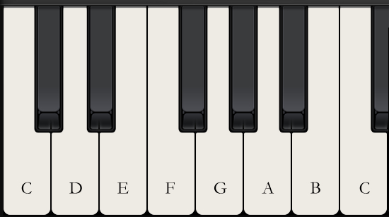

What task should pupils do to complete the revision?
Make sure you can confidently explain the musical elements and be able to use the key terms to explain how a piece of music is put together. You may wish to create flash cards to help you revise the elements. Make sure you are familiar with the Minimalism and Pop music key terms above for your exam as well as the piano layout.

Any other relevant information for pupils

Revision information for Year 9 exams
Subject: PRE
What topics should be revised?
- What is a moral issue?
- Different types of euthanasia.
- Quality and Sanctity of life.
- Religious quotes and teachings about moral issues.
- Case studies about euthanasia.

What task should pupils do to complete the revision?
Create revision flash cards or revision method of your choice.

Any other relevant information for pupils:
Skills
AO1: Demonstrate knowledge and understanding of religion and beliefs.
AO2: Analyse and evaluate aspects of religion and belief, including their significance and influence.
SPaG: 3 marks available. Students must learn the key words spellings off the unit cover sheets in their books and practice using them in sentences to use appropriately in exams.

Revision information for Year 9 exams
Revision information for Year 9 exams

Subject: Resistant Materials
What topics should be revised?
- Workshop Health and Safety
- Safety Equipment and why it is used
- The names of tools and machines and what they are used for (revise the ones we use in lessons in the workshop)
- How to join materials using glue
- How to read a design brief and design a product to match the design brief.
- How to apply surface finishes to wood correctly, key skills and points you need to follow to paint work to a high standard.

What task should pupils do to complete the revision?
Ask questions in lessons to ensure they know key information before their exam
Use the website technologystudent.com to search for useful info about tools and their uses.
Read the WAGOLL sheets and guide sheets used in technology lessons to pick up key information and steps to complete tasks.

Any other relevant information for pupils
The exam will take 1 full lesson to complete in class.

Revision information for Year 9 exams
Subject: Spanish
What topics should be revised?
Personal information.
Holidays.
Food
Present tense.
Past tense.
Future tense.

What task should pupils do to complete the revision?
Learn vocabulary from each topic from the progress booklets on TEAMS.
Learn key structures which could be used in any writing such as opinions, connectives, verbs, detail from the knowledge organisers on TEAMS.

Any other relevant information for pupils
You will be tested in three skills: listening, reading and writing.

Revision information for Year 9 exams
Subject: Textiles
What topics should be revised?
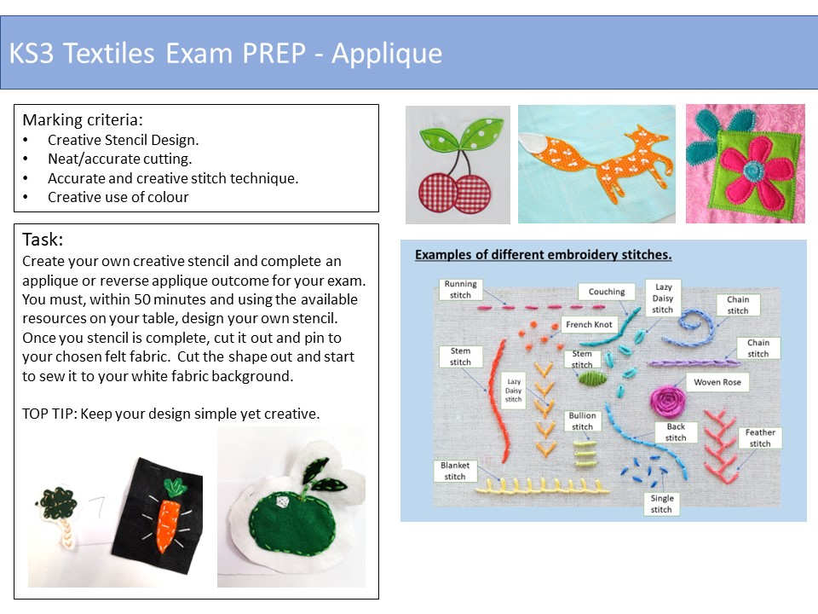.

You will need to revise all theory covered during your Textiles lessons so far. The exam will also require you to use your knowledge from previous years.
You will need to revise all decorative techniques such as; Applique, Tie Dye, Batik, Stencilling, Block printing, Repeat patterns and Embroidery.
You will need to consider types of construction methods and machine techniques including equipment used to complete weaving, felting and the use of bondaweb.

What task should pupils do to complete the revision?
Ask questions in class to support learning topics you are covering.

Any other relevant information for pupils
See page below

